
Computer Networks Lab_241L
UW-24-CS-BS-101
Registration NO:
Muhammad Talha_CS.3ndB
Lab Sessional
UNIVERSITY OF WAH(UOW)

DEPARTMENT OF COMPUTER
SCIENCE

COURSE:

SUBMITTED TO:

Mr. Hassan Shafaqat
SUBMITTED BY:

Adding router to Screen
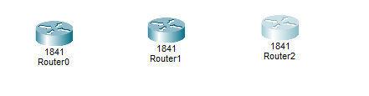
Adding Switches to Screen
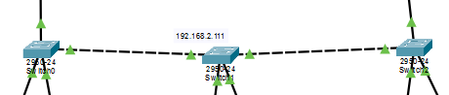
Adding PCs to Screen
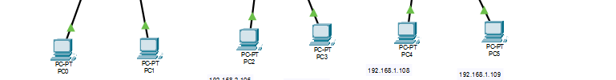
Linking PC to Switches
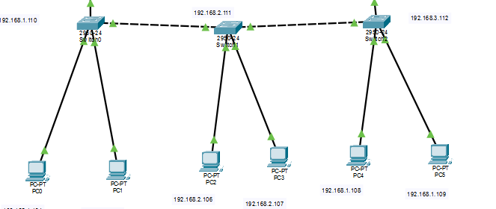

Arranging All network
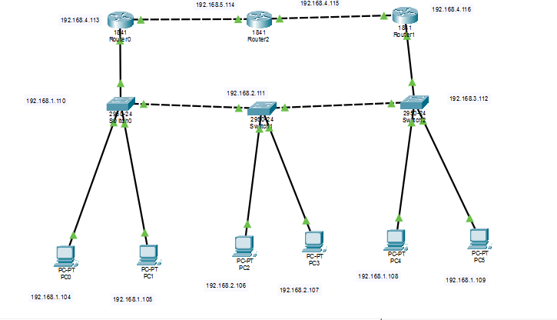
Adding IP address to PCs
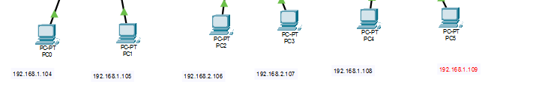
Router 1 (0/0)
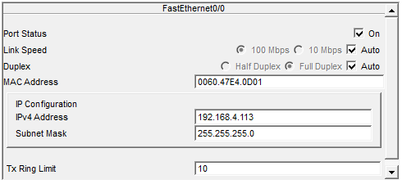
Router 1 (0/1)
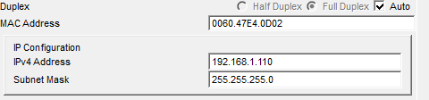

Router 2 (0/0)
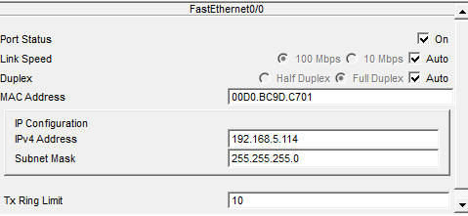
Router 2 (0/1)
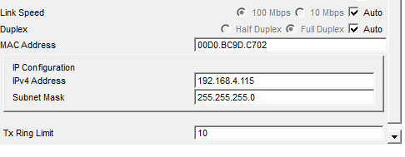
Router 3 (0/0)
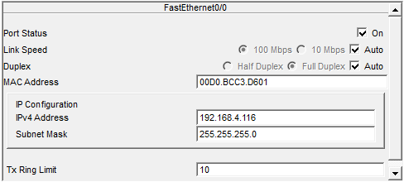
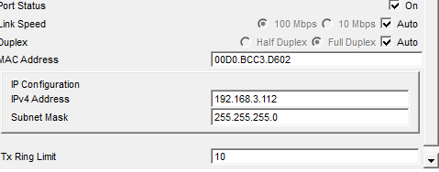

Static Routing Router 1:
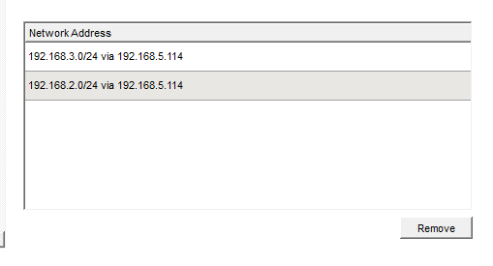
Static Routing Router 2:
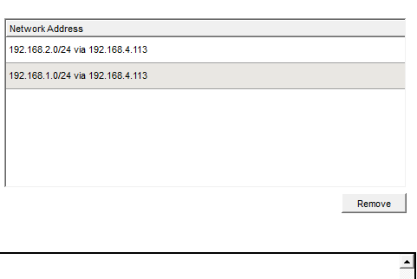
Static Routing Router 3:
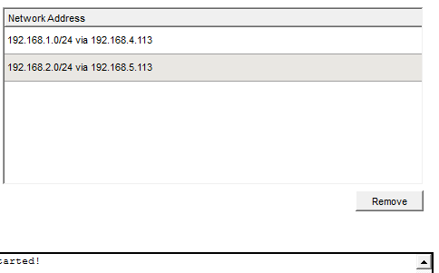

Message sending
PC 1 to all
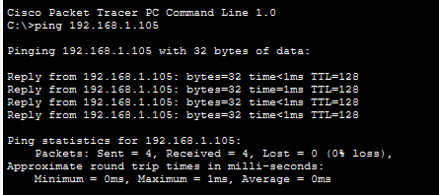
Router 2
To PC1
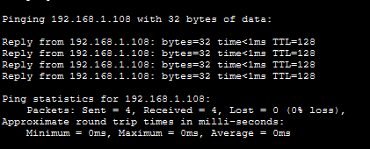
To PC2
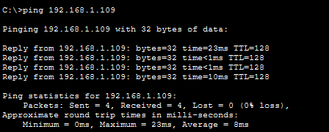

Now PC2 to ALL
Router 2 pc1
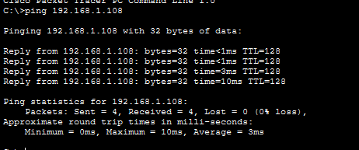

Now Router 2 PC1 to ALL
To Router 1 PC1:
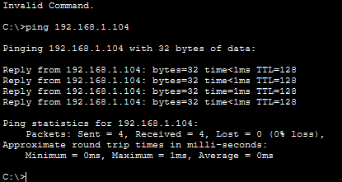
To Router 1 PC2
